Researching Your House or Block in Seattle
Mary Kircher Roddy
www.mkrgenealogy.com mroddyn3@msn.com

All the census records are available for free through the public libraries (Seattle Public and King County). Look for research databases on the library website, category genealogy. Find Heritage Quest. You can search the census records.
If all you have is an address (not a name) it's best to browse the census records. But easiest if you know the Enumeration District (ED) which is how the census is organized at the most basic level. There is a helpful website called the Steve Morse OneStep site. (He has OneStep links for many things like Ellis Island databases, passenger lists and more.) But here is the link for the census ED finder. http://stevemorse.org/census/unified.html You pick your year and you can enter an address and cross streets. That will give you the ED number.
Then you use HeritageQuest through the library. Go to the Seattle Public Library at http://www.spl.org/library-collection/articles-and-research/genealogy and scroll down to the link to HeritageQuest Online. When you click on that you will be prompted to enter your library card number and a PIN (generally the last 4 digits of your phone number.) That will then get you into the census records at Heritage Quest.
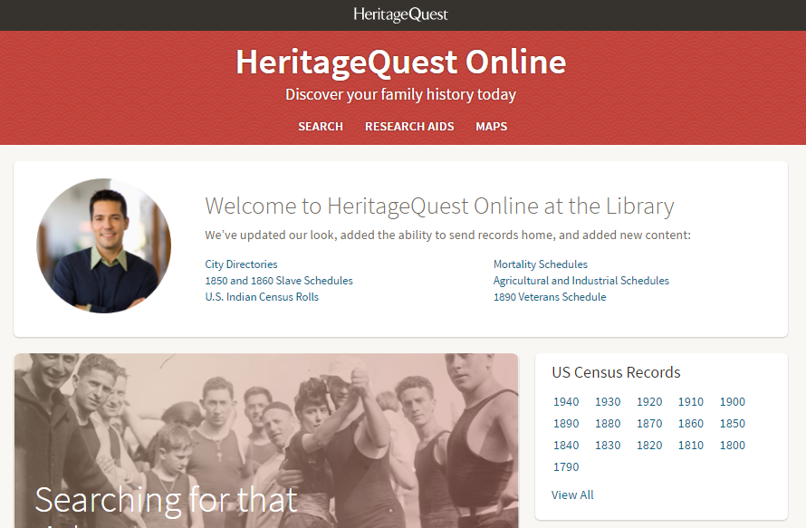
Pick your census year. Then instead of entering a name of a person in the search boxes, you can browse the collection by using state, county, city and then the ED you get from the Steve Morse One Step website. Then you page through to find your address. Note I did this for the Bryant neighborhood of Seattle and there were 93 images (pages) in the 1930 ED and 38 images for 1940.

You can also use Heritage Quest to search in the City Directories by address. Type in the city and county and in the “Keyword” box type the address and click the Exact box.
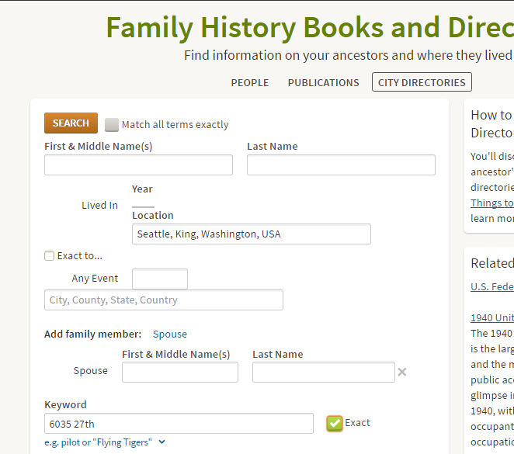
You’ll probably get some hits that aren’t yours (I got one for someone who lived at 16035 27th, and another for someone who lived on 27th and the person immediately below him lived at 6035 8th, and the words on the page were close enough that the computer thought they were linked.

A third way to find more information about your house or your block is by doing address searches in the newspaper. The historical Seattle Times is available for free with a Seattle Public Library card. Go to http://www.spl.org/library-collection/articles-and-research/genealogy and scroll down to the link to Seattle Times (1895 - Current). When you click on that you will be prompted to enter your library card number and then you can search the newspaper database. I typically do two searches: 1) the name of the person and 2) the address. For the address search just do a partial search, ie “6035 27th”. The paper may say “Avenue”,” Ave”, “av” and you don’t know, but if you put in just the house number and street you’ll get most of the hits (you’ll miss some, and I have an entire lecture about searching in newspapers, but this will be at least a good start.)

Another helpful and FREE database at the libraries is the Digital Sanborn Maps. These are fire insurance maps. There are real books of real maps available (some of these are at special collections at UW, I think) but you can use the digital maps to see what your neighborhood looked like at various points in time. You can see the houses, what their construction was made out of (wood, brick, etc). You can see what other kinds of businesses were in the neighborhood (drug store, church, tannery, etc). They are maybe a little complicated to start with - you have to use a key to find which page the particular block you are looking for is on, but once you find it, there is lots of info to be found about the neighborhood.
The maps were created to help fire insurance companies understand what the neighborhood was like so they could assess their risk. No one insurance company would want to insure an entire neighborhood because if a fire got started and decimated the neighborhood they would lose everything. But if they only insured a portion of the structures, they wouldn't have a total loss.

Seattle Public Library has a guide, “Researching the History of Seattle and King County Buildings” available for download at http://cdm16118.contentdm.oclc.org/cdm/landingpage/collection/p16118coll9

